**Experiment no.4**

**Aim** Design and implement RSA algorithm

**Learning Objective:** Student should be able to understand and implement the RSA algorithm.

**Tools:** C/C++/Java/Python or any computational software

### Theory:

RSA encryption algorithm is a type of public-key encryption algorithm. To better understand RSA, lets first understand what is public-key encryption algorithm.

### Public key encryption algorithm:

Public Key encryption algorithm is also called the Asymmetric algorithm. Asymmetric algorithms are those algorithms in which sender and receiver use different keys for encryption and decryption. Each sender is assigned a pair of keys:

* **Public key**
* **Private key**

The **Public key** is used for encryption, and the **Private Key** is used for decryption. Decryption cannot be done using a public key. The two keys are linked, but the private key cannot be derived from the public key. The public key is well known, but the private key is secret and it is known only to the user who owns the key. It means that everybody can send a message to the user using user's public key. But only the user can decrypt the message using his private key.

### The Public key algorithm operates in the following manner:

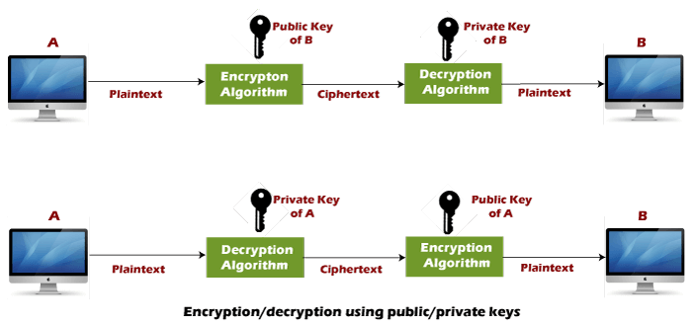

* The data to be sent is encrypted by sender **A** using the public key of the intended receiver
* B decrypts the received ciphertext using its private key, which is known only to B. B replies to A encrypting its message using A's public key.
* A decrypts the received ciphertext using its private key, which is known only to him.

### RSA encryption algorithm:

* Select two large prime numbers, p and **q**.
* Multiply these numbers to find **n = p x q,** where **n** is called the modulus for encryption and decryption.
* Choose a number **e** less than **n**, such that n is relatively prime to **(p - 1) x (q -1).** It means that **e** and **(p - 1) x (q - 1)** have no common factor except 1. Choose "e" such that 1<e < φ (n),e is prime to φ (n),  
  **gcd (e,d(n)) =1**
* If **n = p x q,** then the public key is <e, n>. A plaintext message **m** is encrypted using public key <e, n>. To find ciphertext from the plain text following formula is used to get ciphertext C. \**C = me mod n**  
  Here**, m** must be less than **n**. A larger message (>n) is treated as a concatenation of messages, each of which is encrypted separately.
* To determine the private key, we use the following formula to calculate the d such that:  
  **De mod {(p - 1) x (q - 1)} = 1**  
  **Or** **De mod φ (n) = 1**
* The private key is <d, n>. A ciphertext message **c** is decrypted using private key <d, n>. To calculate plain text **m** from the ciphertext c following formula is used to get plain text m. **m = cd mod n**

RSA is the most common public-key algorithm, named after its inventors **Rivest, Shamir, and Adelman (RSA).**

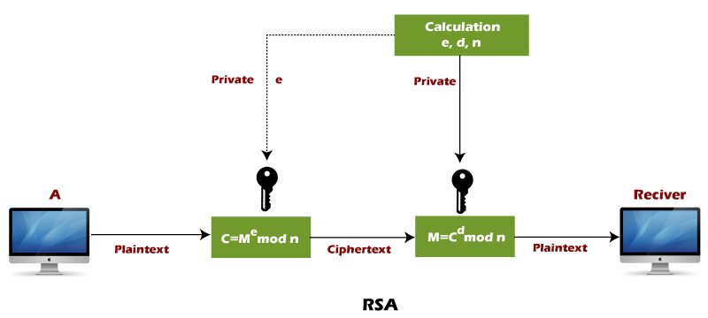

**Program:**

import math

def gcd(a, h):

temp = 0

while(1):

temp = a % h

if (temp == 0):

return h

a = h

h = temp

p = 3

q = 7

n = p*q

e = 2

phi = (p-1)*(q-1)

while (e < phi):

if(gcd(e, phi) == 1):

break

else:

e = e+1

k = 2

d = (1 + (k*phi))/e

msg = 12.0

print("Message data = ", msg)

c = pow(msg, e)

c = math.fmod(c, n)

print("Encrypted data = ", c)

m = pow(c, d)

m = math.fmod(m, n)

print("Original Message Sent = ", m)

**Output:**



**Learning Outcomes:** The student should have the ability to design & implement RSA algorithm using python

LO1: To understand the RSA algorithm.

LO2: To implement RSA algorithm.

**Course Outcomes:** Upon completion of the course students will be able to understand & implement the RSA algorithm.

**Conclusion:**

In this experiment we learned about the RSA algorithm, implemented it using python and even understood how to solve problems related to it.

**For Faculty Use**

|  |  |  |  |  |
| --- | --- | --- | --- | --- |
| **Correction Parameters** | **Formative Assessment [40%]** | **Timely completion of Practical** | **Attendance / Learning Attitude [20%]** |  |
|  |  | **[ 40%]** |  |
| **Marks Obtained** |  |  |  |